FINAL PROJECT DATABASE SYSTEM  
CASE STUDY



Created by:

Group 3 - Games

Marcellino Timothy Martua Hutasoit (xxxxxxxx)

Marchelleo Suhandi (xxxxxxxxxxx)

Satria Ibnu Pamungkas (xxxxxxx)

Table of Contents

Part A 3

Database Design Case Study 3

1. Overview 3

a. Home Page 3

b. Games Page 4

c. Review Page 5

d. About Page 6

e. Contact Page 6

2. Business Rules 7

3. Functionality 8

4. Data Requirements 10

Part B 11

Conceptual Data Modelling 11

1. Overview 11

2. Business Rules 11

3. ERD (Conceptual Data Modelling) and The Justifications 11

Part C 15

Logical Design – Schema Conversion and Normalisation 15

1. Revised Business Rules and Assumption (from Part B) 15

2. Revised ERD of Part B 15

3. Relation (Logical Design/Schema Conversion) 15

4. List of Functional Dependencies Related to Each Business Rule 16

5. Normalisation (Logical Design) 17

Part D 20

Implementation 20

1. The Database 20

2. The Data 20

3. Queries 24

Part E 26

Create a PHP-Based Database Application 26

1. Home Page 26

2. Games Page 27

3. Review Page 28

4. About Page 28

5. Contact Page 29

# Part A

# Database Design Case Study

1. Overview  
   The Gaming Insider is a website that provides information and reviews about various video games. Users can browse the website to find games they are interested in and read reviews and ratings from other users. They can also search for specific games using the search function. Users can submit their reviews of games, but no login or registration is required. The website is designed to be user-friendly and accessible to a wide range of users. Overall, The Gaming Insider aims to provide a comprehensive resource for gamers to find information and reviews about the latest and most popular video games. Here is the content of our website.

### Home Page

The Gaming Insider's Homepage is visually appealing and informative, featuring a carousel showcasing the latest trending games and a list of the top five games chosen by The Gaming Insider. The list includes the game title, genre, publisher, and release year, providing visitors with valuable information. The site's design lets visitors quickly learn about the latest game releases and The Gaming Insider's top recommendations.

### Games Page

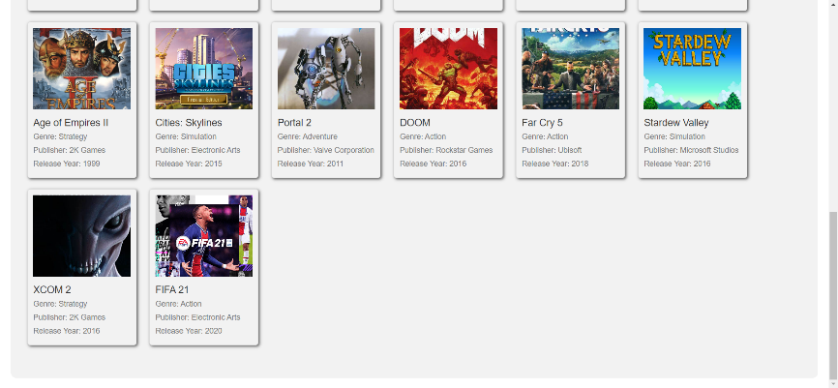

The Games Page lists all the games on the website and their titles, genres, publishers, and release years. The page provides an easy way for visitors to browse through the games and select the ones they want to learn more about. This makes it easier for users to find the information they need about the games they are interested in.

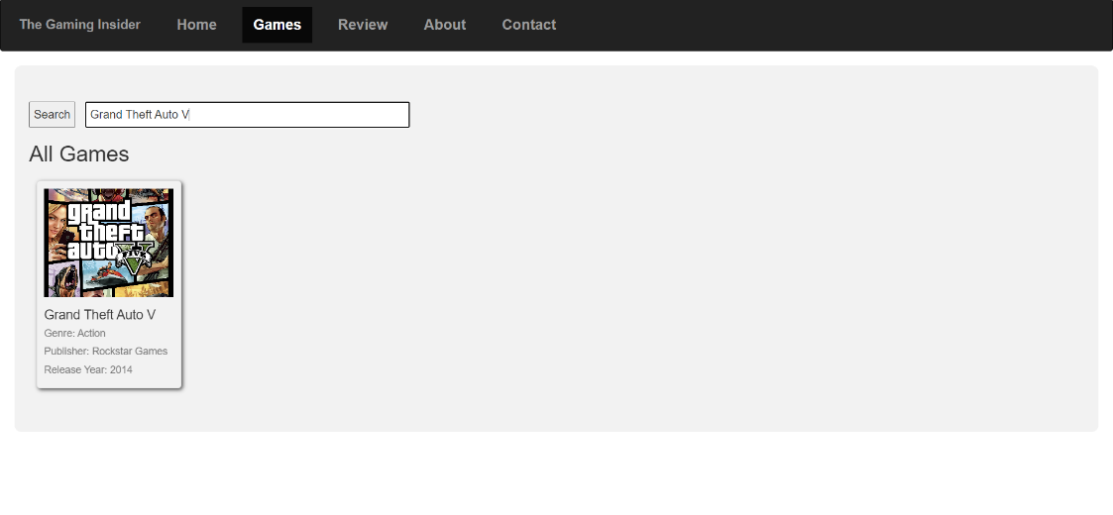The Games Page features a search bar that allows users to search for games based on their titles. Upon entering a title, the search results will display the game's title, genre, publisher, and release year. This feature enables users to easily find and access the game they are looking for.

### Review Page

The Review Page is a page where users can find all reviews submitted by other users, including the game title, author, rating, and review content. Additionally, there is a form available for users to write and submit their reviews, which will be displayed alongside others in the all-review section. This page provides a platform for users to share their opinions and experiences with others who are interested in gaming.

### About Page

The About Page of The Gaming Insider website provides an explanation of the website and the people behind it, including the Project Leader and two members. It gives an overview of the website's purpose and what it aims to achieve.

### Contact Page

The Contact Page on The Gaming Insider website allows users to contact the developers for various reasons, such as requesting additional content, reporting users, giving feedback, reporting bugs, and suggestions. The page includes a form that users can fill out to get in touch with the developers.

## Business Rules

* 1. Game-Platform Relationship:
* A game can be released on multiple platforms, and a platform can host multiple games.
* Each game-platform combination in the "game_platform" table must have a unique ID.
* The release year in the "game_platform" table must be a valid year value.
  1. Review Management:
* Each review in the "review" table must have a unique ID.
* A review must be associated with a specific game using the "game_id" foreign key.
* The "rating" column in the "review" table must be within a specific range (e.g., 1-5) to represent the rating score.
  1. Global Sales Tracking:
* Each game's global sales in the "global_sales" table are recorded with the corresponding "game_id" and the number of sales.
* The "num_sales" column in the "global_sales" table must contain a positive integer value.
  1. Game-Publisher Relationship:
* A game can be published by multiple publishers, and a publisher can publish multiple games.
* Each game-publisher relationship must have a unique ID in the "game_publisher" table.
  1. Platform Information:
* Each gaming platform in the "platform" table must have a unique ID.
* The "platform_name" column in the "platform" table must contain a non-empty name for each platform.
  1. Game Information:
* Each game in the "game" table must have a unique ID.
* The "genre_id" column in the "game" table must reference a valid genre ID from the "genre" table.
* The "game_name" column in the "game" table must contain a non-empty name for each game.
* The "image" column in the "game" table can store the path or URL to the associated image.
  1. Publisher Information:
* Each publisher in the "publisher" table must have a unique ID.
* The "publisher_name" column in the "publisher" table must contain a non-empty name for each publisher.
  1. Genre Information:
* Each genre in the "genre" table must have a unique ID.
* The "genre_name" column in the "genre" table must contain a non-empty name for each genre.
  1. User Management:
* Each user in the "users" table must have a unique username.
* The "username" column in the "users" table must contain a valid email or username format.
* The "password" column in the "users" table should store encrypted or hashed passwords for security.
  1. Admin Access:
* The "admin" table represents the system administrator, and each administrator must have a unique username.
* The "username" column in the "admin" table must reference an existing user's username from the "users" table.
* The "password" column in the "admin" table should store encrypted or hashed passwords for security.

## Functionality

* 1. User Registration:

Users can register on the website by providing necessary information such as username, full name, email, and password. This function involves exchanging data between the front-end user and the system.

* 1. Game Browsing:

Users can browse a list of games available on the website. The system provides information about the game's title, release date, platform, and genre. Data is passed between the front-end user and the system during the browsing process.

* 1. Game Search:

Users can search for games using keywords or filters such as platform, genre, or release date. The system allows users to find specific games based on their preferences. Data related to the search parameters are exchanged between the user and the system.

* 1. Game Details:

Users can view detailed information about a game, including the game's image, release year, genre, publisher, reviews, and ratings. The system retrieves and presents this data to the user based on their selection.

* 1. Review Submission:

Users can write reviews for games they have played. This function involves the user submitting a rating out of five and a written description of their experience with the game. The system stores the review data provided by the user.

* 1. Review Reading:

Users can read reviews written by other users. The system presents reviews to the user, allowing them to sort and filter reviews based on rating or relevance.

* 1. Social Media Sharing:

Users can share information about a game or their reviews on social media platforms. The system provides options for users to share game-related content with their social media networks.

* 1. Support Contact:

Users can contact support for various purposes such as reporting bugs, asking for help, or providing feedback about the website. This function enables users to communicate their concerns or inquiries to the support team.

* 1. Responsive Design:

The website should have a responsive design that adapts to different screen sizes and devices, including desktops, laptops, tablets, and mobile phones. The system ensures that the website's layout and functionality are optimized for a seamless user experience across different devices.

## Data Requirements

* Users: The database must include a table to store information about users, including the username, full_name, and password.
* Admin: The database must include a table to store information about administrators, including the username and password.
* Game: The database must include a table to store information about video games, including the id, genre_id, game_name, and image.
* Genre: The database must include a table to store information about video game genres, including their and genre_name.
* Publisher: The database must include a table to store information about video game publishers, including the publisher_id and publisher_name.
* Game Publisher: The database must include a table to store the relationship between video games and their publishers, including the id, game_id, and publisher_id.
* Platform: The database must include a table to store information about video game platforms, including the platform id and platform_name.
* Game Platform: The database must include a table to store the relationship between video games and their platforms, including id, game_publisher_id, platform_id, and release_year.
* Global Sales: The database must include a table to store information about video game sales in Global, including the game_id and num_sales.
* Review: The database must include a table to store reviews of video games, including the review id, game title, author, review text, and rating.

# Part B

# Conceptual Data Modelling

1. Overview  
   The Gaming Insider website is a platform that provides various features for game enthusiasts. The website has a Home Page that displays a carousel of new games and a list of the top five games recommended by The Gaming Insider. The Games Page provides a search bar for users to search for their favorite games by title and displays the game's title, genre, publisher, and release year. The Review Page displays all user reviews and the game's title, author, rating, and review content. The Contact Page allows users to send feedback, suggestions, and bug reports through a form provided on the website.

## Business Rules

The A.2 Business Rules is already the final version.

## ERD (Conceptual Data Modelling) and The Justifications

* 1. List Of PK and FK
     1. game_platform
        + id (PK)
        + game_publisher_id (FK (game_publisher_id) REFERENCES game_publisher(id))
        + platform_id (FK (platform_id) REFERENCES platform(id))
        + release_year
     2. review
        + id (PK)
        + game_id
        + author
        + review
        + rating
     3. global_sales
        + game_id (PK) (FK (game_id) REFERENCES game(id))
        + num_sales
     4. game_publisher
        + id (PK)
        + game_id (FK (game_id) REFERENCES game(id))
        + publisher_id (FK (publisher_id) REFERENCES publisher(id))
     5. platform
        + id (PK)
        + platform_name
     6. game
        + id (PK)
        + genre_id (FK (genre_id) REFERENCES genre(id))
        + game_name
        + image
     7. publisher
        + id (PK)
        + platform_name
     8. genre
        + id (PK)
        + genre_name
     9. users
        + username (PK)
        + full_name
        + password
     10. admin
         + username (PK) (FK (username) REFERENCES users(username)
         + password
  2. Justifications

1. game_platform:

* Each game can be released on multiple platforms, and each platform can host multiple games. This represents a many-to-many relationship between the game and the platform.
* The game_platform table includes a unique ID for each game-platform combination.
* The release_year attribute ensures that the release year is stored as a valid year value.

1. review:

* Each review must have a unique ID.
* A review is associated with a specific game using the game_id foreign key.
* The rating attribute is limited to a specific range (e.g., 1-5) to represent the rating score.

1. global_sales:

* The global_sales table records the number of sales for each game using the game_id as a foreign key.
* The num_sales attribute ensures that it contains a positive integer value.

1. game_publisher:

* A game can be published by multiple publishers, and a publisher can publish multiple games. This represents a many-to-many relationship between the game and the publisher.
* The game_publisher table includes a unique ID for each game-publisher relationship.

1. platform:

* Each gaming platform has a unique ID.
* The platform_name attribute ensures that each platform has a non-empty name.

1. game:

* Each game has a unique ID.
* The genre_id attribute references a valid genre ID from the genre table.
* The game_name attribute ensures that each game has a non-empty name.
* The image attribute can store the path or URL to the associated image.

1. publisher:

* Each publisher has a unique ID.
* The publisher_name attribute ensures that each publisher has a non-empty name.

1. genre:

* Each genre has a unique ID.
* The genre_name attribute ensures that each genre has a non-empty name.

1. users:

* Each user has a unique username.
* The username attribute should contain a valid email or username format.
* The password attribute should store encrypted or hashed passwords for security.

1. admin:

* The admin table represents system administrators.
* Each administrator has a unique username that references an existing user's username from the users table.
* The password attribute should store encrypted or hashed passwords for security.

# Part C

# Logical Design – Schema Conversion and Normalisation

## Revised Business Rules and Assumption (from Part B)

The A.2 Business Rules is already the final version.

## Revised ERD of Part B

The B.3 ERD is already the final version.

## Relation (Logical Design/Schema Conversion)

1. game_platform

* PK: id
* FK: game_publisher_id (references game_publisher(id)), platform_id (references platform(id))
* Attributes: release_year

1. review

* PK: id
* FK: game_id (references game(id))
* Attributes: author, review, rating

1. global_sales

* PK: game_id (references game(id))
* Attributes: num_sales

1. game_publisher

* PK: id
* FK: game_id (references game(id)), publisher_id (references publisher(id))

1. platform

* PK: id
* Attributes: platform_name

1. game

* PK: id
* FK: genre_id (references genre(id))
* Attributes: game_name, image

1. publisher

* PK: id
* Attributes: platform_name

1. genre

* PK: id
* Attributes: genre_name

1. users

* PK: username
* Attributes: full_name, password

1. admin

* PK: username (references users(username))
* Attributes: password

## List of Functional Dependencies Related to Each Business Rule

* 1. Game-Platform Relationship:

game_platform.id → {game_platform.game_publisher_id, game_platform.platform_id, game_platform.release_year}

* 1. Review Management:

review.id → {review.game_id, review.author, review.review, review.rating}

* 1. Global Sales Tracking:

global_sales.game_id → {global_sales.num_sales}

* 1. Game-Publisher Relationship:

game_publisher.id → {game_publisher.game_id, game_publisher.publisher_id}

* 1. Platform Information:

platform.id → {platform.platform_name}

* 1. Game Information:

game.id → {game.genre_id, game.game_name, game.image}

* 1. Publisher Information:

publisher.id → {publisher.publisher_name}

* 1. Genre Information:

genre.id → {genre.genre_name}

* 1. User Management:

users.id → {users.name, users.email, users.password}

* 1. Admin Access:

admin.username → {admin.password}

## Normalisation (Logical Design)

1. game_platform:

* PK: id
* FK: game_publisher_id (references game_publisher(id)), platform_id (references platform(id))
* Attributes: release_year

Functional Dependencies:

* id → game_publisher_id
* id → platform_id

The "game_platform" table is already in the 3rd normal form (3NF) as all attributes are atomic, and there are no transitive dependencies.

1. review:

* PK: id
* FK: game_id (references game(id))
* Attributes: author, review, rating

Functional Dependencies:

* id → game_id

The "review" table is already in the 3rd normal form (3NF) as all attributes are atomic, and there are no transitive dependencies.

1. global_sales:

* PK: game_id (references game(id))
* Attributes: num_sales

The "global_sales" table is already in the 3rd normal form (3NF) as all attributes are atomic, and there are no transitive dependencies.

1. game_publisher:

* PK: id
* FK: game_id (references game(id)), publisher_id (references publisher(id))

Functional Dependencies:

* id → game_id
* id → publisher_id

The "game_publisher" table is already in the 3rd normal form (3NF) as all attributes are atomic, and there are no transitive dependencies.

1. platform:

* PK: id
* Attributes: platform_name

The "platform" table is already in the 3rd normal form (3NF) as all attributes are atomic, and there are no transitive dependencies.

1. game:

* PK: id
* FK: genre_id (references genre(id))
* Attributes: game_name, image

Functional Dependencies:

* id → genre_id

The "game" table is already in the 3rd normal form (3NF) as all attributes are atomic, and there are no transitive dependencies.

1. publisher:

* PK: id
* Attributes: platform_name

The "publisher" table is already in the 3rd normal form (3NF) as all attributes are atomic, and there are no transitive dependencies.

1. genre:

* PK: id
* Attributes: genre_name

The "genre" table is already in the 3rd normal form (3NF) as all attributes are atomic, and there are no transitive dependencies.

1. users:

* PK: username
* Attributes: full_name, password

The "users" table is already in the 3rd normal form (3NF) as all attributes are atomic, and there are no transitive dependencies.

1. admin:

* PK: username (references users(username))
* Attributes: password

The "admin" table is already in the 3rd normal form (3NF) as all attributes are atomic, and there are no transitive dependencies.

All the tables are already in the 3rd normal form (3NF), so no further normalization is required.

# **Part D**

# **Implementation**

## The Database

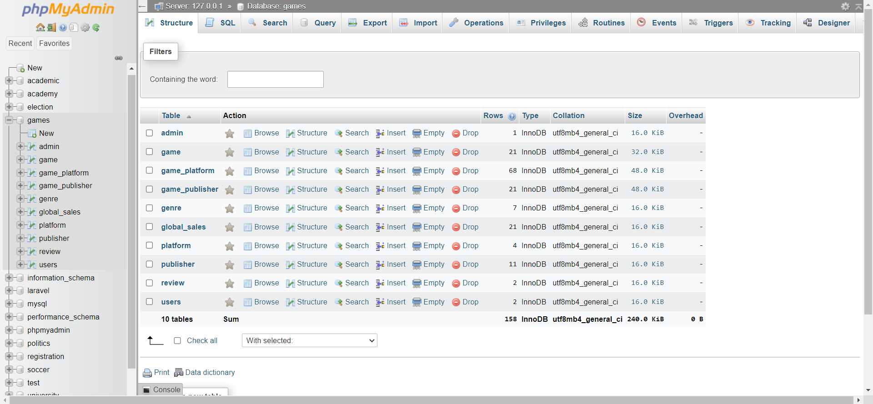

## The Data

Data of Users who have registered on the website

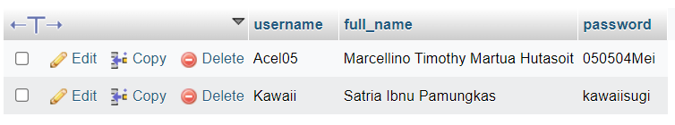

Data of Admins who have registered on the website

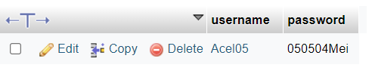

Data of Games that are available on the website

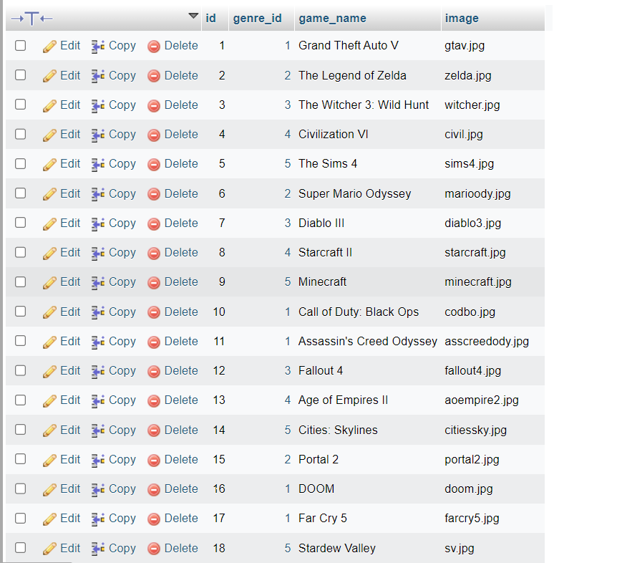

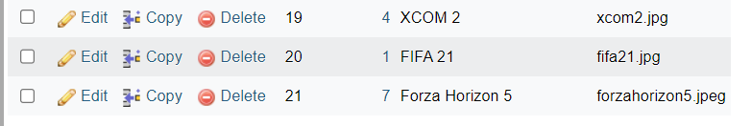

Data of Genres that are available on the website

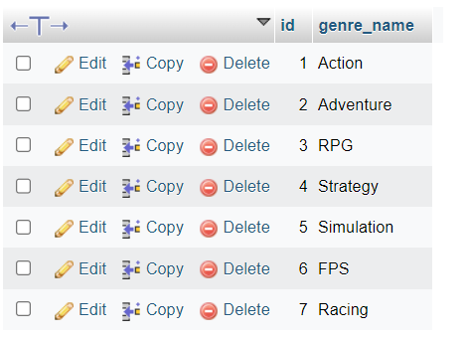

Data of Publishers that are available on the website

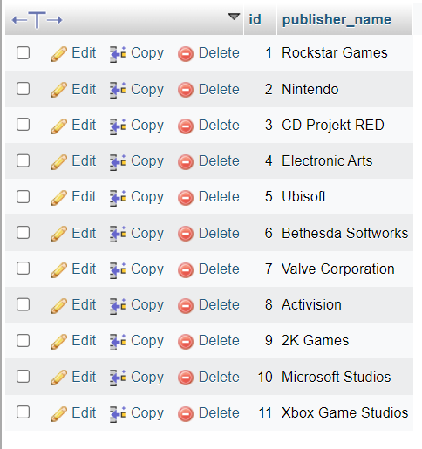

Data of Platforms that are available on the website

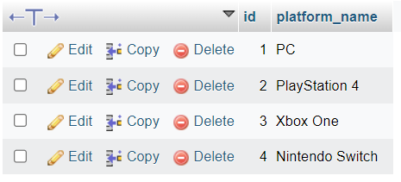

Data on Global Sales available on the website

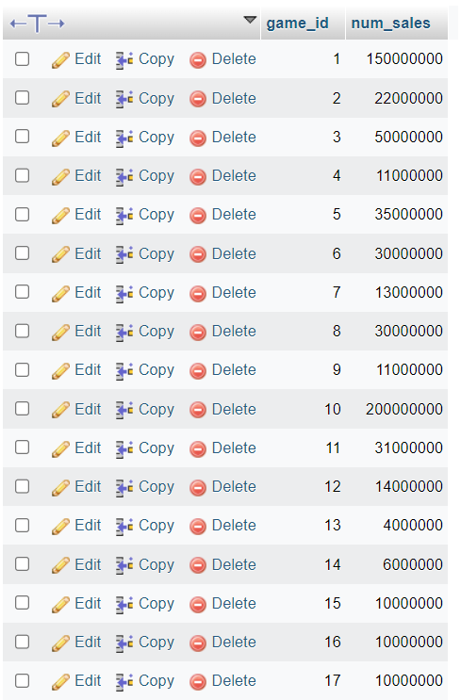

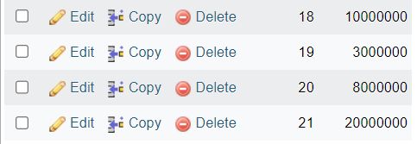

## Queries

The query used to display data in the web's game list section leverages the aggregate function "MIN(game_platform.release_year)" to retrieve the earliest release year for each game. The "GROUP BY" clause is employed to define the grouping criteria, ensuring that the aggregate function operates on specific subsets of data.

The query utilizes "INNER JOIN" statements to consolidate relevant information from multiple tables. These statements facilitate the integration of data based on their relationships, allowing for the retrieval of interconnected information from different tables.

Overall, this query enables the extraction of game data, including the game name, genre name, publisher name, game image, earliest release year, and the corresponding number of sales. The query provides a comprehensive and organized result set by joining tables using their associated keys.

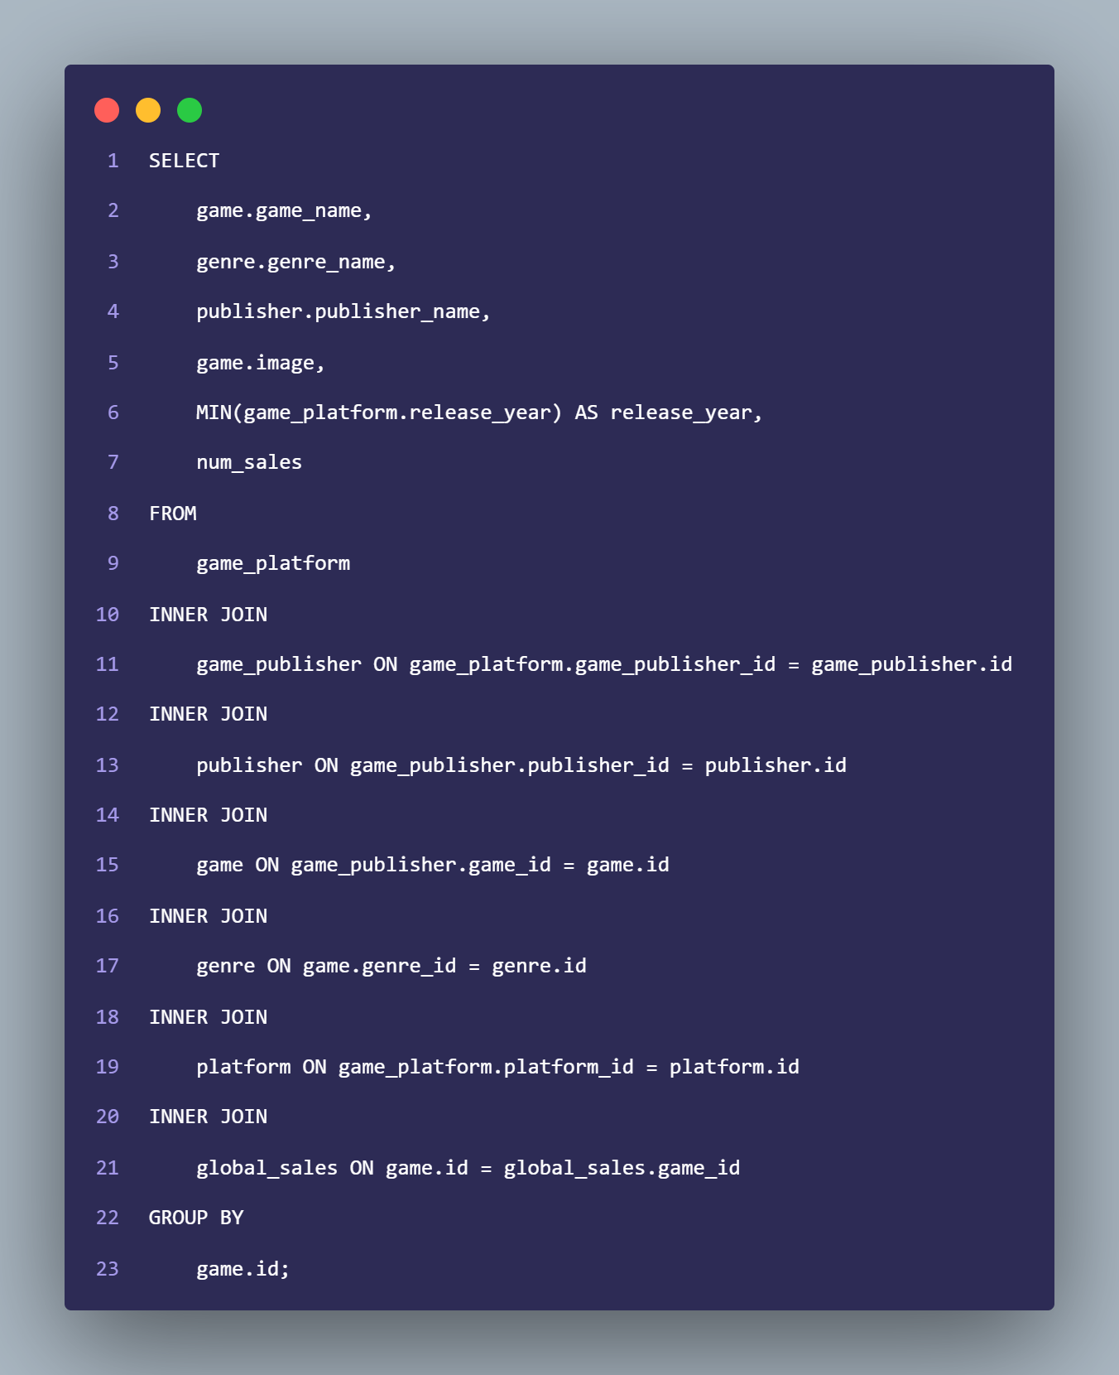

# **Part E**

# **Create a PHP-Based Database Application**

### Home Page

The Gaming Insider's Homepage is visually appealing and informative, featuring a carousel showcasing the latest trending games and a list of the top five games chosen by The Gaming Insider. The list includes the game title, genre, publisher, and release year, providing visitors with valuable information. The site's design lets visitors quickly learn about the latest game releases and The Gaming Insider's top recommendations.

### Games Page



The Games Page lists all the games on the website and their titles, genres, publishers, and release years. The page provides an easy way for visitors to browse through the games and select the ones they want to learn more about. This makes it easier for users to find the information they need about the games they are interested in.

The Games Page features a search bar that allows users to search for games based on their titles. Upon entering a title, the search results will display the game's title, genre, publisher, and release year. This feature enables users to easily find and access the game they are looking for.

### Review Page

The Review Page is a page where users can find all reviews submitted by other users, including the game title, author, rating, and review content. Additionally, there is a form available for users to write and submit their reviews, which will be displayed alongside others in the all-review section. This page provides a platform for users to share their opinions and experiences with others who are interested in gaming.

### About Page

The About Page of The Gaming Insider website provides an explanation of the website and the people behind it, including the Project Leader and two members. It gives an overview of the website's purpose and what it aims to achieve.

### Contact Page

The Contact Page on The Gaming Insider website allows users to contact the developers for various reasons, such as requesting additional content, reporting users, giving feedback, reporting bugs, and suggestions. The page includes a form that users can fill out to get in touch with the developers.